
PB-T2/ENQP/1221/B 28-APR-2022
PREBOARD EXAMINATION 3-TERM II (2021-2022)
Subject: ENGLISH CORE  Grade: 12 |  | Max. Marks:40  Time:2 Hrs
Name: |  |  | Section: | Roll No:
General Instructions:
- The Question Paper contains THREE sections-READING, WRITING and LITERATURE.
- Attempt questions based on specific instructions for each part.
 | SECTION A - READING: 14 Marks
1. | Read the passage given below:
 | 1.For one month after they left the nest, I led my four young ravens at least once and sometimes several times a day on thirty-minute walks. During these walks, I wrote down everything in their environment they pecked at. In the first sessions, I tried to be teacher. I touched specific objects—sticks, moss, rocks—and nothing that I touched remained untouched by them. They came to investigate what I had investigated, leading me to assume that young birds are aided in learning to identify food from the parents’ example. They also, however, contacted almost everything else that lay directly in their own paths. They soon became more independent by taking their own routes near mine.
 | 2.Even while walking along on their own, they pulled at leaves, grass stems, flowers, bark, pine needles, seeds, cones, clods of earth, and other objects they encountered. I wrote all this down, converting it to numbers. After they were thoroughly familiar with the background objects in these woods and started to ignore them, I seeded the path we would later walk together with objects they had never before encountered. Some of these were conspicuous food items: raspberries, dead meal worm beetles, and cooked corn kernels. Others were conspicuous and inedible: pebbles, glass chips, red winterberries. Still others were such highly cryptic foods as encased caddisfly larvae and moth cocoons. The results were dramatic. The four young birds on our daily walks contacted all new objects preferentially. They picked them out at a rate of up to tens of thousands of times greater than background or previously contacted objects.
 | 3.The main initial criterion for pecking or picking anything up was its novelty. In subsequent trials, when the previously novel items were edible, they became preferred and the inedible objects became “background” items, just like the leaves, grass, and pebbles, even if they were highly conspicuous. These experiments showed that ravens’ curiosity ensures exposure to all or almost all items in the environment.
 | Based on your understanding of the passage, answer ANY EIGHT questions from the  nine given below. |  |  |  | 1x8=8
i. | Cite a point in evidence from the text that aided the author to deduce the fact that young ravens emulate their parent’s skill. |  |  |  | 1
ii. | According to the experiment described in the passage, whether the author’s ravens continued to show interest in a formerly new object was dictated primarily by whether that object was __________. |  |  |  | 1
iii. | Replace the underlined word in the following sentence with a suitable synonym:  The four young birds on our daily walks contacted all new objects preferentially. |  |  |  | 1
iv. | How does the author intentionally make the birds aware of his presence in his first sessions? |  |  |  | 1
v. | Select a suitable word from paragraph (1-2) to replace the underlined word in the following sentence retaining the same meaning.  One of the chairs pushed back from the table, and this was so astonishing and mysterious that Dorothy was almost tempted to run away in fright. |  |  |  | 1
vi. | Why is the response of the ravens said to be dramatic during the second session of experimenting? |  |  |  | 1
vii. | What resulted in the birds to overlook the background items which initially attracted them? |  |  |  | 1
viii. | Rewrite the given sentence by replacing the underlined word by its synonym from paragraph 3.  He wrote, at his best, in the grand manner, melody and thought according with perfection of expression, and his finest poems have that indefinable air of the inevitable which is after all the touchstone of the poetic quality. |  |  |  | 1
ix. | Identify one trait that is shared by both the author and his ravens. |  |  |  | 1
2. | Read the passage given below:
 | 1.Many Canadians are aware that problems with the nation’s health care system have resulted in a lack of hospital beds and medical equipment, overcrowded emergency rooms, long surgical and diagnostic waiting lists, and not enough long-term care homes. But with 3.6 million Canadians unable to find a family doctor, a particularly insidious and growing problem is making itself evident.
 | 2.The family doctor is the cornerstone of the nation’s health care system. The vast majority of Canadians have said many times over that they want their family doctor to be their first point of contact in the health care system. Nevertheless, family doctors are becoming a dying breed. With diminishing access to that first point of contact, many Canadians in need of medical help are finding it increasingly difficult to receive timely and appropriate care. In my province of British Columbia, the conservative estimate is that 200,000 British Columbians looking for a family doctor cannot find one.
 | 3.There are many reasons for this predicament. Over the last 10 years, the number of medical students choosing family practice as their lifelong career has been dropping at a startling rate. It used to be that 50% of students chose family practice as their first choice. As of 1997, that proportion had fallen to 35%; in 2004, it has declined further to 24%. At a time when the population is living longer and increasing in size, these are alarming statistics.
 | 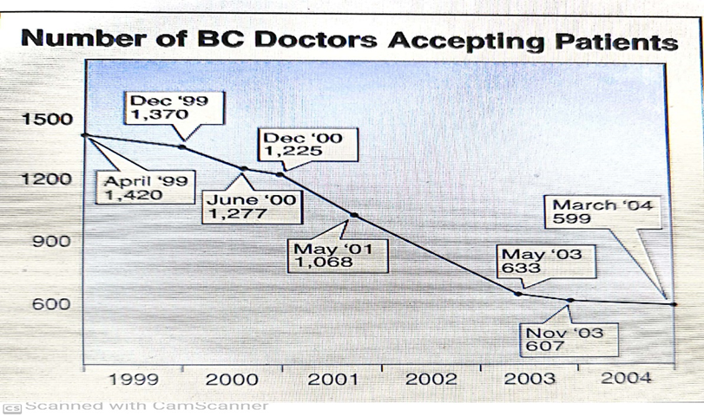
 | 4.When asked why they lack interest in family medicine, students cite a daunting student debt load (often more than $100,000 upon graduation) and the long hours required of a doctor who is managing a family practice. As in other kinds of work, young doctors today want a balance between their professional and personal lives.
 | 5.In BC this problem is compounded because the province produces fewer medical graduates per capita than any other province in Canada with a medical school. The number of graduates in BC is slowly rising – this year the University of British Columbia faculty of medicine graduated 128 students, up from 120. The provincial government has committed itself to doubling the number of medical student graduates to 256. When residency programs are taken into account, however, we will not see the full effects of this initiative until sometime between 2016 and 2019. This strategy doesn’t come close to giving us the 400 new doctors needed each year in BC to replace those who are retiring, moving out of the province, reducing their hours of practice, or dying. And at our current rate, we can expect only a small percentage of these new recruits to choose family medicine.
 | 6.The primary care system is showing its cracks. Ten years ago, 2,030 of BC’s family doctors (about half of the GP population) were providing obstetrical care. Today just 945 are performing this invaluable service. Although delivering babies is a “good news” area of medicine, the hours are long, malpractice insurance premiums are high and the remuneration for bringing new life into the world is modest. The result is that obstetrics is too much for many family physicians to contend with today. Comprehensive family practices see an increasing number of patients, many of whom have an expanding number of complex health problems. In addition, many more patients than in the past are in a “holding pattern” with conditions that are being monitored by their family doctor while they wait for specialist appointments and care.
 | 7.It’s no surprise, then, that many of BC’s family doctors are no longer taking on new patients. In 1999, there were 1,420 family doctors accepting new patients – in 2004 that number declined to 599, a drop of 58%. 8 The foundation of primary care needs to be strengthened in order for it to be sustained. The Working Agreement between the doctors and government, ratified in July 2004, by our membership of 8,000, includes a series of primary care renewal projects designed to make family practice more attractive to medical graduates, improve upon working conditions, and entice family doctors from outside BC to hang up their shingles here. Yet still more needs to be done.
 | Based on your understanding of the passage, answer ANY SIX out of the seven  questions given below. |  |  |  | 1x6=6
i. | According to medical students, what is responsible for their reluctance to become family physicians? |  |  |  | 1
ii. | The literary device used in “The primary care system is showing its cracks” is ___________ (Paragraph 6) |  |  |  | 1
iii. | With reference to Figure 1, which time period on the chart shows the greatest decrease in the number of BC doctors accepting patients? |  |  |  | 1
iv. | The passage highlights a stark mismatch between __________________________. |  |  |  | 1
v. | What do you understand by the term, ‘holding pattern’, as stated in paragraph 6? |  |  |  | 1
vi. | As per the narrator, what are the steps taken to save the dying breed of family doctors? |  |  |  | 1
vii. | What does the narrator mean by ‘cornerstone of health care system,’ in paragraph 2? |  |  |  | 1
 | SECTION B-WRITING (8 marks)
3. | You are opening a recording studio with all latest trends of technology. Write an informal invitation to your best friend inviting him/her for the inauguration in not more than 50 words. |  |  |  | 3
4.  A.  B. | Attempt ANY ONE from A and B given below.  Tushar Sharma, a graduate from National School of Drama and resident of Safdarjung Enclave, Delhi comes across an advertisement of the Prithvi Theatres, Mumbai asking for applications from theatre actors for their new play. Write the application in about 120-150 words inventing details wherever necessary.  (OR)  You were one of the participants at a Science Symposium organized at the national level by CBSE during the summer vacation. You were very impressed by the high standard of discussion that took place during the session. You have been asked to write a report for the school magazine about the symposium and its relevance in today’s world. Write the report in 120-150 words inventing details wherever necessary. You are Rohit Mehta. |  |  |  | 5
 | SECTION C- LITERATURE -18 marks
5. | Attempt ANY FIVE of the six questions given below, within 40 words each. |  |  |  | 2x5=10
i. | Keats evoked his readers through his powers of imagination. Cite evidence from the poem, ‘A thing of beauty’ in support of this statement. |  |  |  | 2
ii. | How does Lagerlof draw parallelism between the physical warmth and coldness that runs in the setting of the story and the cold and warm treatment that the peddler receives from his fellow beings? |  |  |  | 2
iii. | Aunt Jennifer as described in the poem insists on creating, remaining resilient and perseverant. Justify the statement with evidence from the poem. |  |  |  | 2
iv. | “That was a long story”. What does Clare want to convey through this assertion? |  |  |  | 2
v. | Lamb keeps his garden gates open always and has no curtains for his open windows at home. Describe the mindset of the character revealed here. |  |  |  | 2
vi. | How do we know from the lesson, Indigo that ordinary people too contributed to the freedom movement? |  |  |  | 2
6. | Answer ANY TWO of the following in about 120-150 words each.
i. | A tension between appearances and reality runs throughout the story which is filled with deception and disguises. Dexter ultimately highlights the theme that making judgments based on appearances is an unproductive habit, and that people and situations are not always what they seem. Substantiate with reference to text. |  |  |  | 4
ii. | “Things that matter. Things nobody else has ever said. Things I want to think about. “What are the things that Derry is referring to? How does Derry’s chance meeting with Mr. Lamb prove meaningful for him? |  |  |  | 4
iii. | “Unexpected kindness is the most powerful, least costly and the most underrated agent of human change” Examine the lives of both the rattrap seller and Derry to authenticate the quote. |  |  |  | 4
***

